**The Poona Gujrati Kelavani Mandal’s**

**Haribhai V. Desai Collenge, PUNE**

Re-accredited with “A” Grade by NAAC

**Department of Computer Science**

**A**

**Project Report**

**On**

**Caring for Life**

In partial fulfillment of requirements for the degree of

Bachelor of Science

Computer Science

SUBMITTED BY :

1. **Ashish Kushwaha 3833**
2. **Abhay Parihar 3842**

Under the Guidance of

Mrs. Vishakha Tambe

**CERTIFICATE**

This is to certify that the project entitled “ CARING FOR LIFE ” has been carried out by the team under my guidance in partial fulfillment of the degree of Bachelor of Science (Computer Science) of “Savitribai Phule Pune University” during the academic year of 2016-2017.

Team:

1. **Ashish Kushwaha 3833**
2. **Abhay Parihar 3842**

**Project Guide Head, Computer Science Department**

Mrs.Vishakha tambe

**Date :**

**PROJECT APPROVAL SHEET**

Following team has done the appropriate work related to the “ CARING FOR LIFE ” in partial fulfillment for the award of Bachelor of Science ( Computer Science ) of “ Savitribai Phule Pune University “ and is being submitted to H.V. DESAI, Pune.

**Project Guide :** Mrs. Vishakha Tambe

**Date :**

**External Examiner :**

**ACKNOWLEDGEMENT**

For performing our project, we had to take help and guideline of some respected persons who deserves our greatest gratitude. We would like to show our gratitude to Mr. Vishakha tambe, Project guide for giving us good guideline for project throughout numerous consultations. We would also like to expand our deepest gratitude to whole Comp.Sci. Department, H.V.Desai College who have guided us regarding the Validations.

We would also like to thank our teachers Mrs. Shubda mam and Ritukamal Jangira mam who’s ways of teaching the concepts was beneficial for our project, Jyoti Kanse mam gives us presentation tips for project.

Special thanks to our parents & friends who have supported us whenever we faced the difficulties and time we needed them most.

**INDEX**

1. Introduction of system

a)Problem Definition

b)Scope of System

2.System Analysis

a)Hardware and software Requirememt

b)Feasibility Study

i)Technical Feasibility

ii)Economical Feasibility

iii)Operational Feasibility

3.System Design

a)E-R Diagram

b)Data Dictionary

c)UML Diagrams

i)Component daigram

ii)Use case diagram

iii)Activity diagram

iv)Sequence diagram

v)Deployment diagram

4.Input Screens

5.Limitations and Future Enhancement of the system

6.Testing

7.Biblography

**INTRODUCTION**

Caring for Life is a medical caring system which primarily focuses on the basic needs of an patients in emergency.This project is proposed for any type of user to provide easy ways for caring of his/her life.

It will reduces the problems occurs to users during any critical condition.

1.1 ) Detailed Problem Definition-A emergency is a serious ,unexpected ,often dangerous situation that requires immediate action. Medical emergencies are common in older peoples.They may have difficulty accessing suitable health care. Newly shifted peoples form one place to another place are unknown to new place

Hospitals, clinic, Medical stores, Bloodbanks and doctor clinics. This will creates problem to those peoples in emergency time. Storing and carring medical reports in hard copy for long time is so dificult.

* 1. **Need for the New System**

Need for the New System-To solve above problems we proposed this project .

This will make our work easy and reliable.

**Project Scope**

The proposed system is web-based. Therefore,it can be accessed from anywhere.

**Proposed System and its advantages:**

a)Speedy Operations: The proposed system being computerized to carry out operations at incredibly high speed within seconds.

b)Accuracy: Computers are well known for their accuracy.

c)Mobility:Hence data is stored in computer we can move and modify data more easily and when required from one computer to another using its peripheral devices.

d)Non-Redundancy:The data is stored in computers. Computers can be connected to each other by a network so different departments may not store the same data individually. This helps in non-redundancy of data.

**2. ANALYSIS**

**2.1 Software and hardware requirements**

Software Requirement Specification

a)PHP

b)CSS

c)Postgresql for the database

d)JavaScript

e)Apache

Hardware Requirement Specification

a)Hardware devices like Mouse, Keyboard etc.

b)Hard Disk 256GB.

c)RAM 1GB.

**2.2 Feasibility Study**

Feasibility is the measure of how beneficial or practical the development of an information system will be to organize. An important outcome of the preliminary system is determination that the aspect of request that the aspect of request is feasible. There are 3 aspects of feasibility study.

**Technical Feasibility**:

The project is web based.

Operating system required is RHL6.

SQL (postgesql) is required for database.

Web browser for internet access.

HTML, PHP, JavaScript, CSS required for frontend.

We use Intel Microprocessor.

Hard Disk 256GB.

RAM 1GB.

**Economical Feasibility:**

As Linux is open end software operating system is required at very low cost or free.

HTML, PHP, JavaScript is free of cost.

Internet connection cost depends on service provider.

RAM, Hard Disk, Motherboard, CPU, cabinet etc. are required.

**Operational Feasibility:**

The website which is been developed by our team is very user friendly, anyone with basic knowledge can use it.

**SYSTEM DESIGN**

**3.a)Entity Relationship Diagram -:**

USER

IS A

REGISTER USERS

USER

ADMIN

Upload Reports

View / Dlelete / Send Reports

Reports

**3.b)Database Table Design**

1. **UserDetails -:**

|  |  |  |  |  |  |  |  |  |  |  |  |
| --- | --- | --- | --- | --- | --- | --- | --- | --- | --- | --- | --- |
| **Id** | **F_name** | **L_name** | **Email** | **Contact** | **Address** | **Gender** | **Dob** | **Password** | **sQues** | **sAns** | **test** |
| **int** | **Varchar (20)** | **Varchar (20)** | **Varchar (20)** | **numeric** | **Varchar (20)** | **Varchar (2)** | **Date** | **Varchar (20)** | **Varchar (50)** | **Varchar (50)** | **Int** |

1**.user Table**

|  |  |  |
| --- | --- | --- |
| **Field** | **Data type** | **Key** |
| **Id** | **Int** | **Primary key** |

**2. file_upload –:**

**2**

|  |  |  |  |  |
| --- | --- | --- | --- | --- |
| **Id** | **File** | **type** | **Size** | **User_id** |
| **Int** | **Text** | **text** | **Text** | **Integer** |

**.**

**3.file_upload-:**

|  |  |  |
| --- | --- | --- |
| **Field** | **Data type** | **Key** |
| **Id** | **Int** | **Forign key** |

**3.c)UML Diagrams**

**3.c.1)Use Case Diagram**

System

Admin

User

Login

Register New User

Manage User

Upload / View / DeleteReports

Gets Services

<<Include>>

**3.c.2)Sequence Diagram**

User

System



Register

login

<<



Terminated

L

o

g

o

u

t

admin



login,

view user.



Login Successful

Upload Reports

View / Delete / Send

Access various user information

logout

**3.c.3)State Diagram**

r

LOGIN

REGISTRATION

REGISTER

USER

ADMIN

AS A

USER

AS A

ADMIN

Upload Reports

View / Delete / Send

Reports

Call Ambulance,

Buy accessories

HANDLE MASTER

DATA

UPDATE,INSERT

DELETE

MASTER DATA

USER PROFILE

ADMIN PROFILE

**3.c.2) Activity Diagram**

Login

if

New User

Old User

if

Password

Match

if

Admin

User

User

Register

New User

ivgive

If registered

user

Upload

Reports

View / Delete /

send

Edit/Delete

View Profile

Filter

Password

Match

Logout

**3.c.4)** Deployment Diagram

Application

Apache Web Server

Postgresql Database

**Input Screen**

**Home Screen :**

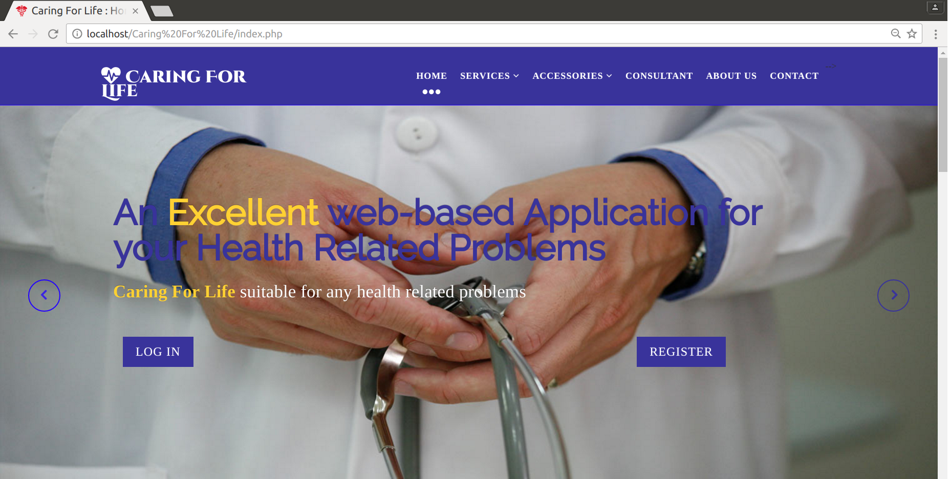

**Registeration Screen (For New User):**

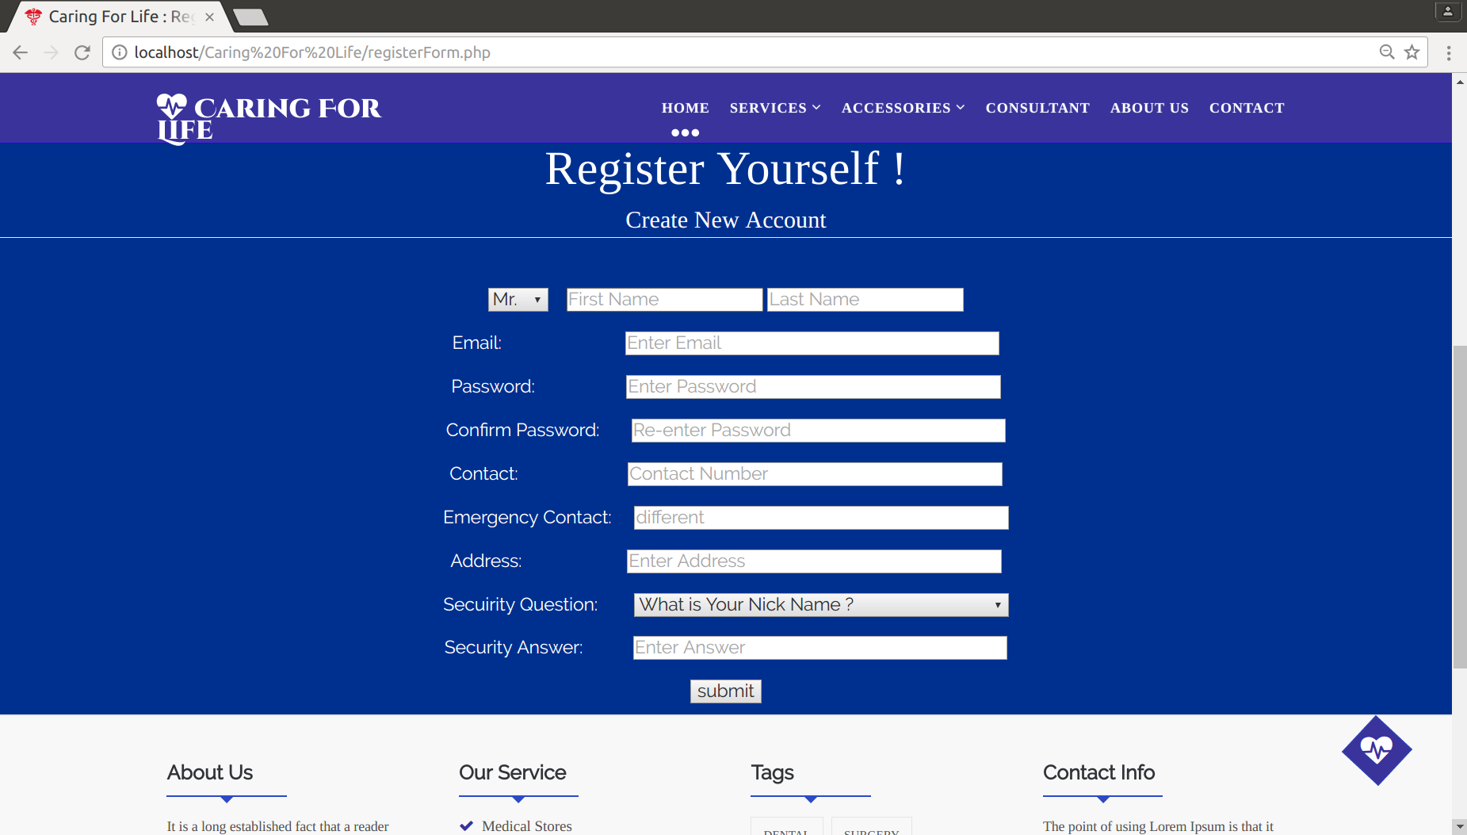

**Login Screen :**

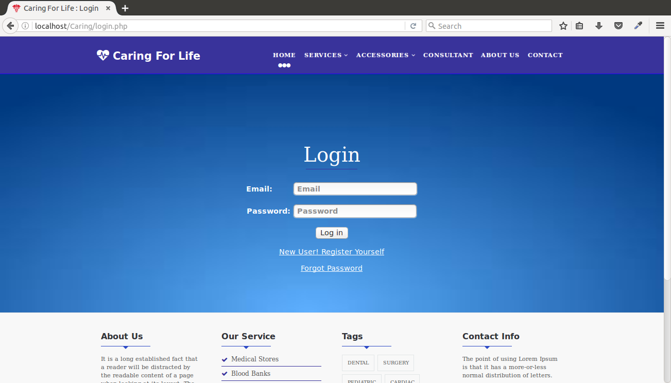

**Admin Home Screen :**

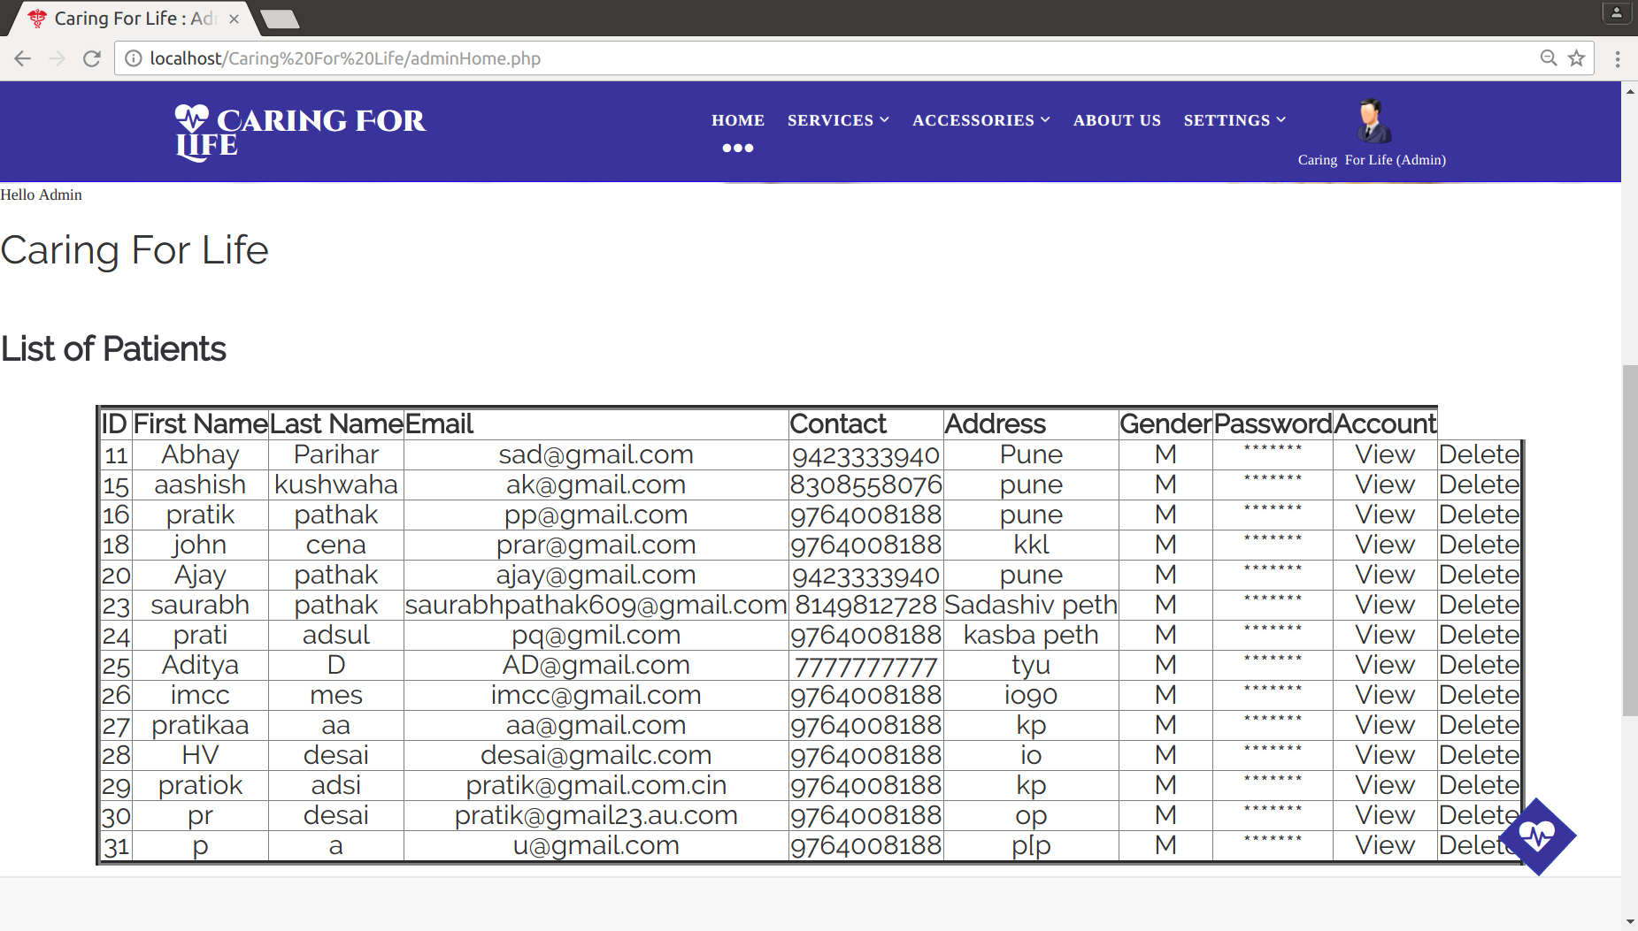

**User Home Screen:**

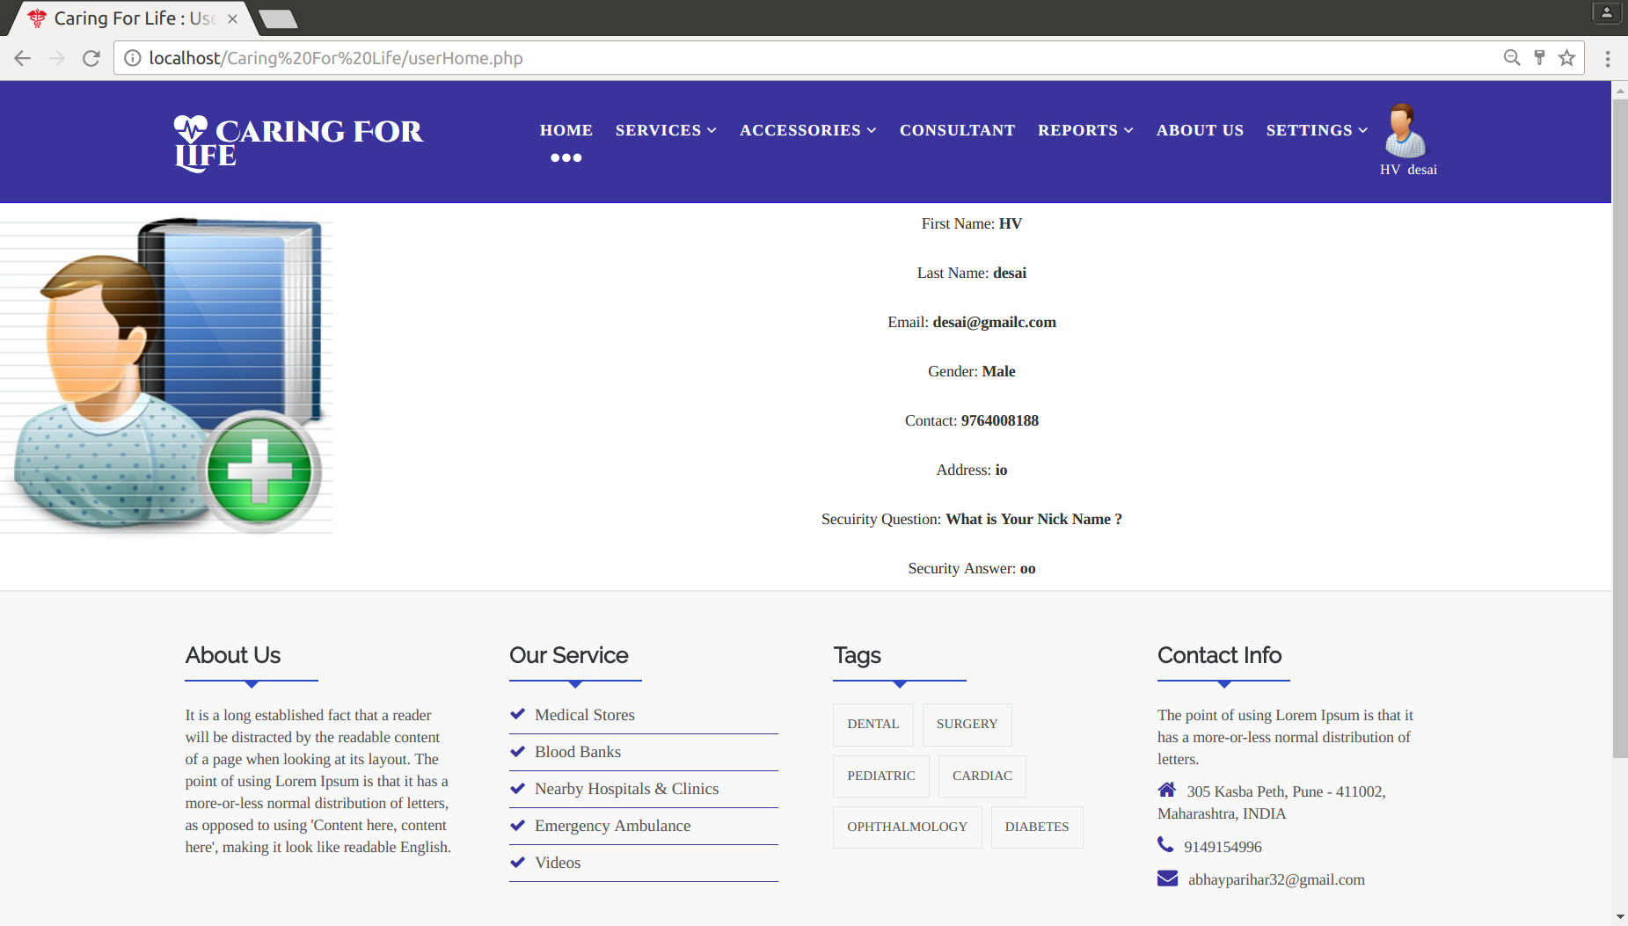

**Services Window (Medical Stores):**

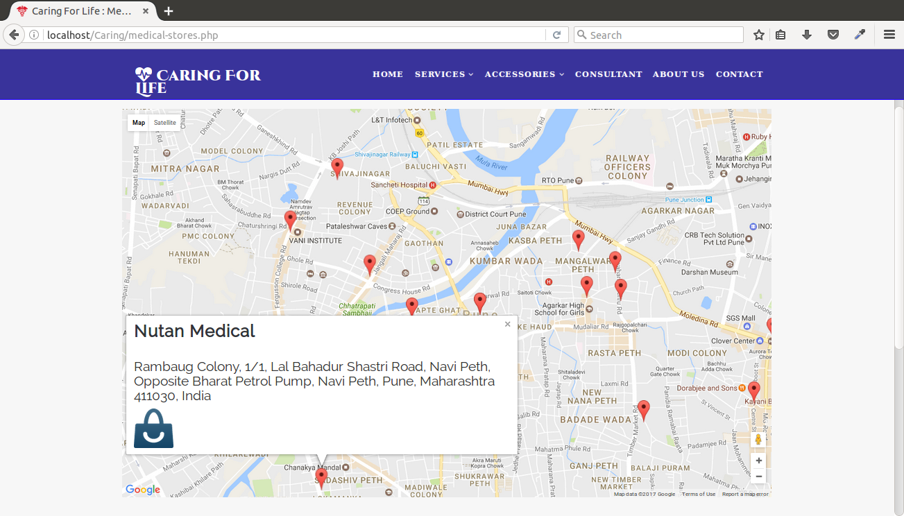

**Validations :**

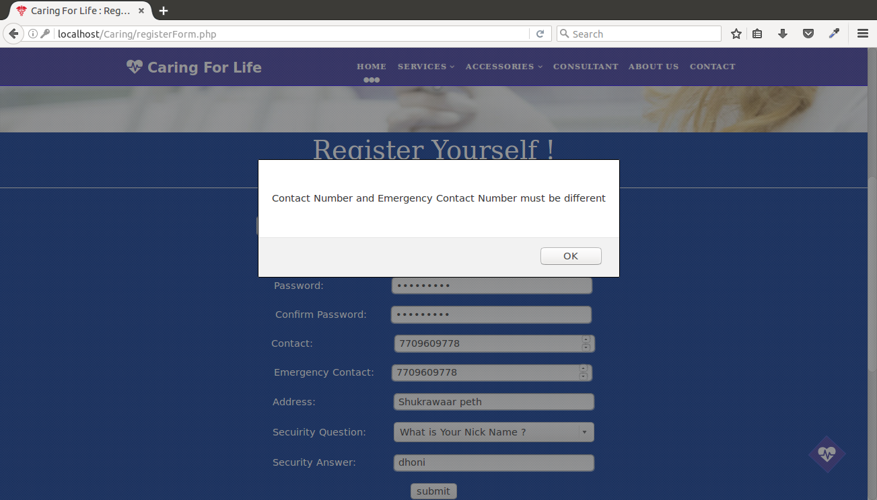

**Consultancy Window-:**

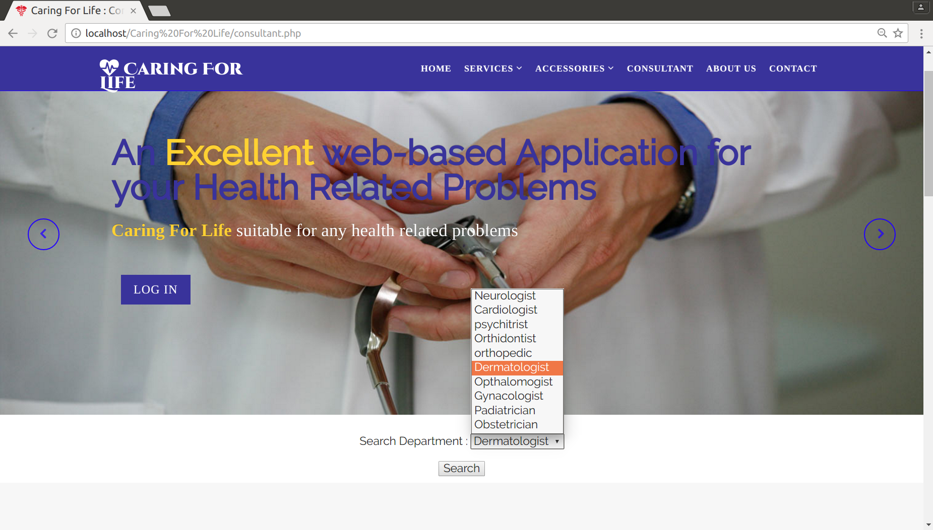

**Video Section Screen:**

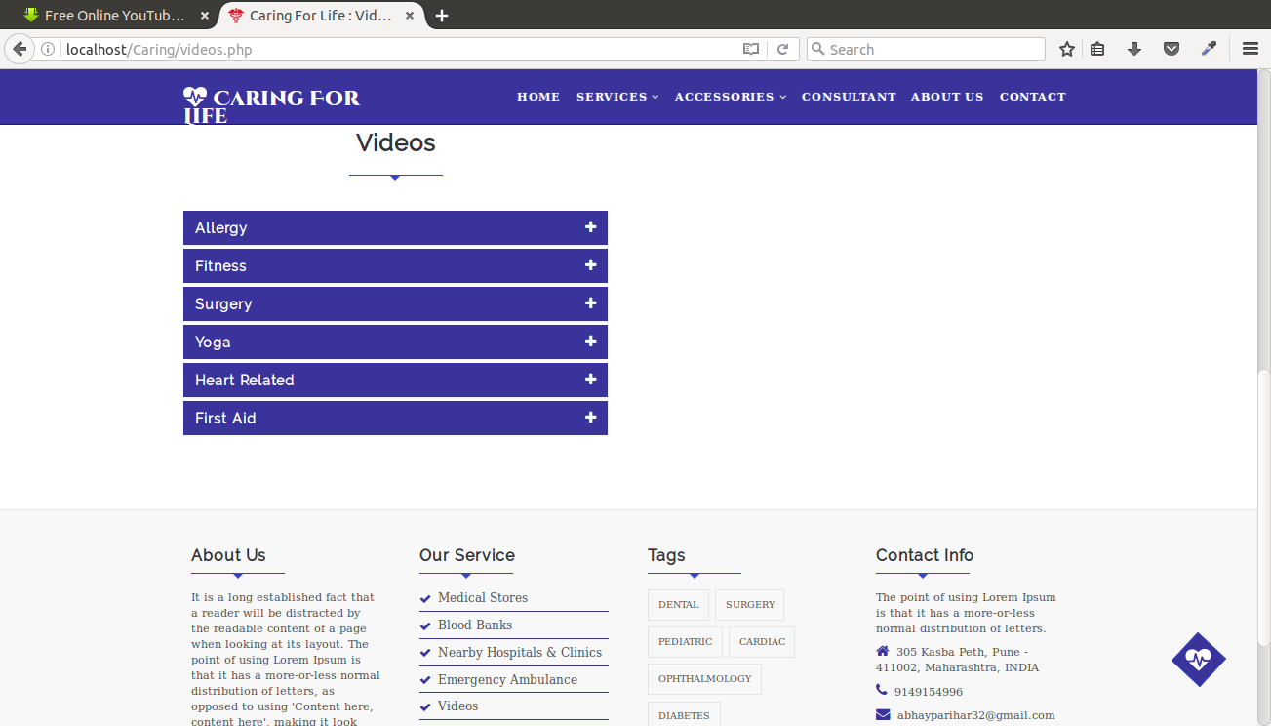

**File Uploading Window :**

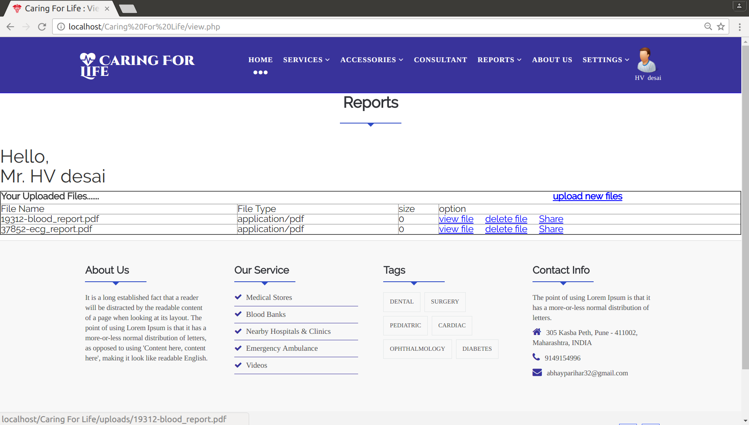

**EMERGENCY AMBULANCE-:**

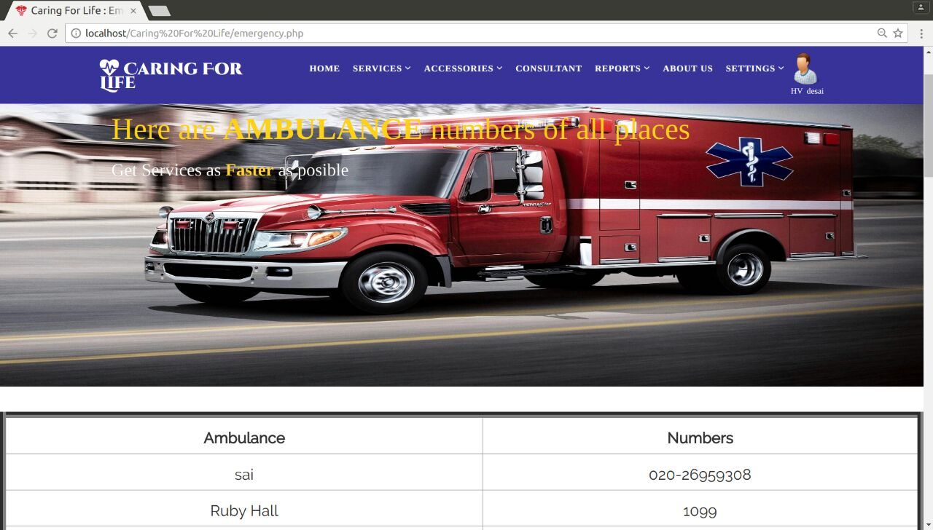

**EMAIL SEND-:**

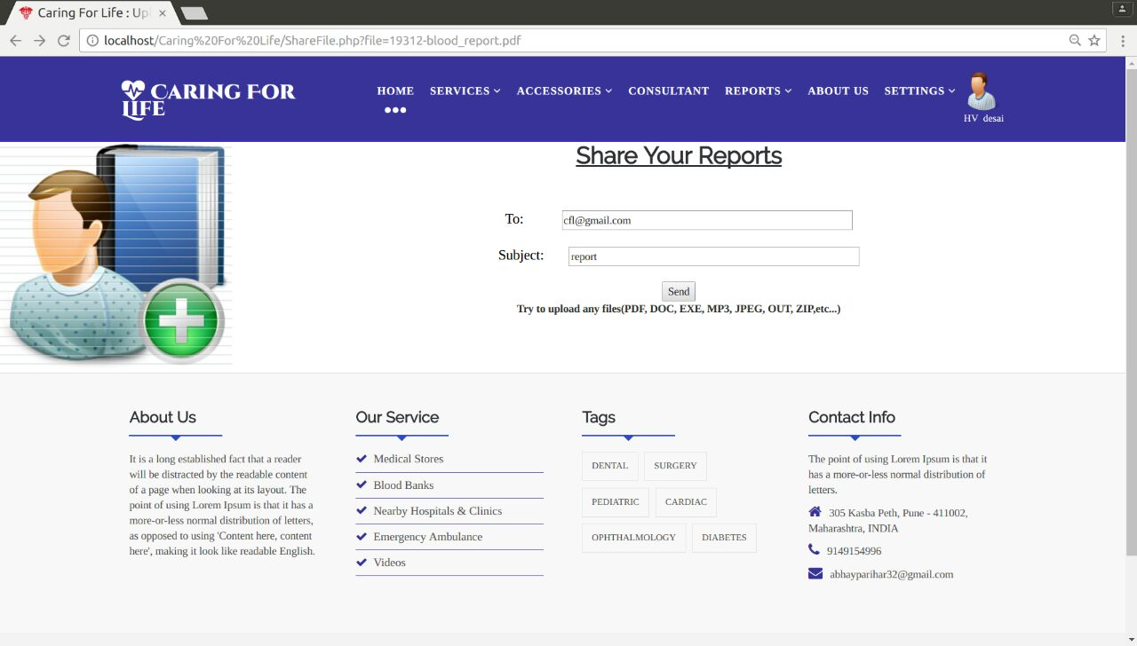

**Mobile Message Screen :**

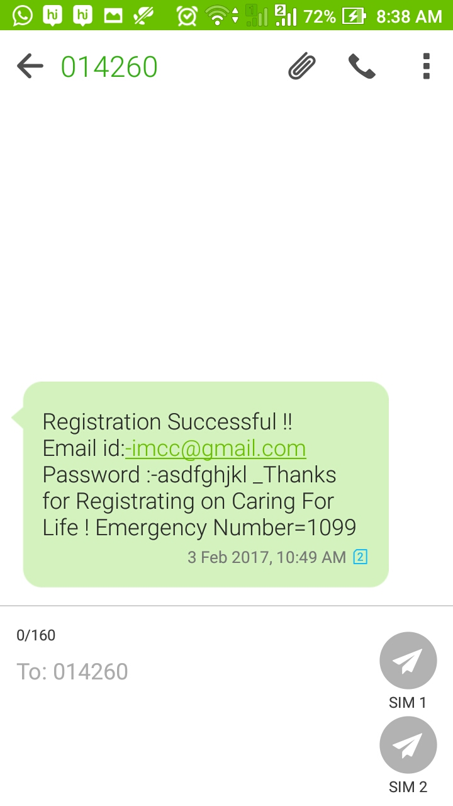

**CODING**

**5.1 Hardware Specifications :**

Mother Board : Genuine Intel 2.80 Ghz

Processor : x86_64 (64 bits)

RAM : 1 GB

HDD : 250 GB

**5.2 Platform :**

OS : Linux Red Hat 6 ( College )

Ubuntu 14.4 LTS ( Home )

**5.3 Programming Language used :**

PHP Hypertext Pre-processor (one of the most popular Open Source server-side Programming Language) with PostgreSQL (one of the most popular and Robust open source Relational Database Management System) And JavaScript (Dynamic Programming Language along with HTML) for Client-side Validations.

**5.4 Coding style followed :**

* We have used PHP as a Programming Language for subsequent reasons :

- PHP is Free

- PHP allows Platform Diversity

- Load Time is Very Less

- Database Flexibility

- Server Side Scripting

* We have used Procedural or Modular approach in coding ie. Code is divided into more than one functions.
* Since code is quite large, so we have tried to keep it well indented to make it more readable.
* Use of comments helped us to keep co-ordination among the terms & to understand the purpose of specific module eventually.

**TESTING**

**6.1 Test cases & Test Results**

**6.1.1 Test Case 1 – Login Screen**

* **Incorrect Input :** Incorrect User ID or Password
* **Pass Criteria :** One should enter Valid User ID and Password
* **Correct Input :** User or Admin should need to enter Valid User ID & Password to proceed further.
* **Result :** Successfull

**6.1.2 Test Case 2 – New User Registration**

* **Incorrect Input :** Any Input field have been empty
* **Pass Criteria :** One should fill all fields before submitting.
* **Correct Input :** User need to fill all input fields before submitting the Registration form according to their equivalent data types.

**6.1.3 Test Case 3 – Logout Option**

* **Incorrect Input :** After Logout, again trying to go back to Home Screen
* **Pass Criteria :** One should need to do Login again.
* **Correct Input :** User or Admin should need to Login again to visit Home Screen back after Logout. ( This is because, after click on Logout all Sessions gets Unset and then Destroyed. )

**LIMITATIONS AND FUTURE ENHANCEMENT**

**Our Enhancement**

1) Mobile messaging: During registeration For New User you hava to fill Two different Contact No. After submiting on Registeration Form user will Get an Message on Both Conatct which you are provided During registeration.

In message user will get his Email Address & password From CaringFor Life..........

2) E-mail Facility:After registeration user can get our Service which is user can upload his Reports on server, After that he can also Share it to others through email.

**Future Enhancement**

1) Apponitment: On apponitment window ,user can take apptioment with doctors

after apptionment for confirmation user will get an mesage of his/her appointment

time and date as per your convienence...

**REFERENCES AND BIBLIOGRAPHY**

[1]Website Referred -:

* [www.w3schools.com](http://www.w3schools.com)

* [www.Google.com](http://www.Google.com)

[2] Refernece Book of PHP